SIMATS ENGINEERING
ASSESSMENT TOOL I — Uncertainty Visualization Lab
Course: Data Handling and Visualization | Code: DSA06 | CO: CO5
Duration: 180 min | Total Marks: 100 | Reg No : 192524029  Name:KAILASH M

COURSE OUTCOME COVERED
CO3: Analyze time-series data, trends, associations, and uncertainty through appropriate visualization methods. (BL4)
Activity Tool : Uncertainty Visualization Lab
Weightage: 20%
Code of Conduct:
I KAILASH M (192524029) certify that this submission is my original work and that I have adhered to the guidelines specified for this assessment. I understand that any violation of academic integrity rules will result in disciplinary action.
Signature of the student: KAILASH M

Criteria | Understanding of Uncertainty  25% | Visualization of Uncertainty  25% | Application of Visualization Principles  20% | Organization 20% | Accuracy 10% | Clarity 5% | Total
Q1
Q2
Q3
Q4
Q5

Uncertainty Visualization Lab – Assessment Tool
R Programming Practical Questions with Datasets
Instructions: Answer all five questions. Use R programming to construct the required visualization, interpret uncertainty, and identify potential visualization pitfalls. Use the given data exactly unless a transformation is explicitly requested.

Q1 — Bootstrapping and 95% Confidence Interval
The question asks you to calculate the sample mean, generate at least 5,000 bootstrap resamples, calculate a 95% bootstrap confidence interval, and visualize the bootstrap distribution with the observed mean.
# Q1: Bootstrapping and Confidence Interval

# Data
delivery_time <- c(31, 35, 28, 42, 37, 33,
45, 29, 39, 34, 41, 36)

# Calculate sample mean
observed_mean <- mean(delivery_time)

# Print observed mean
cat("Sample Mean:", observed_mean, "minutes\n")

# Number of bootstrap resamples
B <- 5000

# Set seed for reproducibility
set.seed(123)

# Bootstrap resampling
bootstrap_means <- replicate(
B,
mean(sample(delivery_time,
size = length(delivery_time),
replace = TRUE))
)

# Calculate 95% bootstrap confidence interval
CI <- quantile(bootstrap_means,
probs = c(0.025, 0.975))

# Print confidence interval
cat("95% Bootstrap Confidence Interval:\n")
print(CI)

# Histogram of bootstrap distribution
hist(bootstrap_means,
breaks = 30,
main = "Bootstrap Distribution of Mean Delivery Time",
xlab = "Bootstrap Mean (minutes)",
probability = TRUE)

# Add density curve
lines(density(bootstrap_means), lwd = 2)

# Mark observed mean
abline(v = observed_mean,
lwd = 2,
lty = 2)

# Add legend
legend("topright",
legend = "Observed Mean",
lty = 2,
lwd = 2)

Expected result
- Sample mean: approximately 35.83 minutes
- The histogram shows the distribution of the 5,000 bootstrap sample means.
- The dashed vertical line represents the observed sample mean.
- The 95% bootstrap CI gives the plausible range for the population mean delivery time
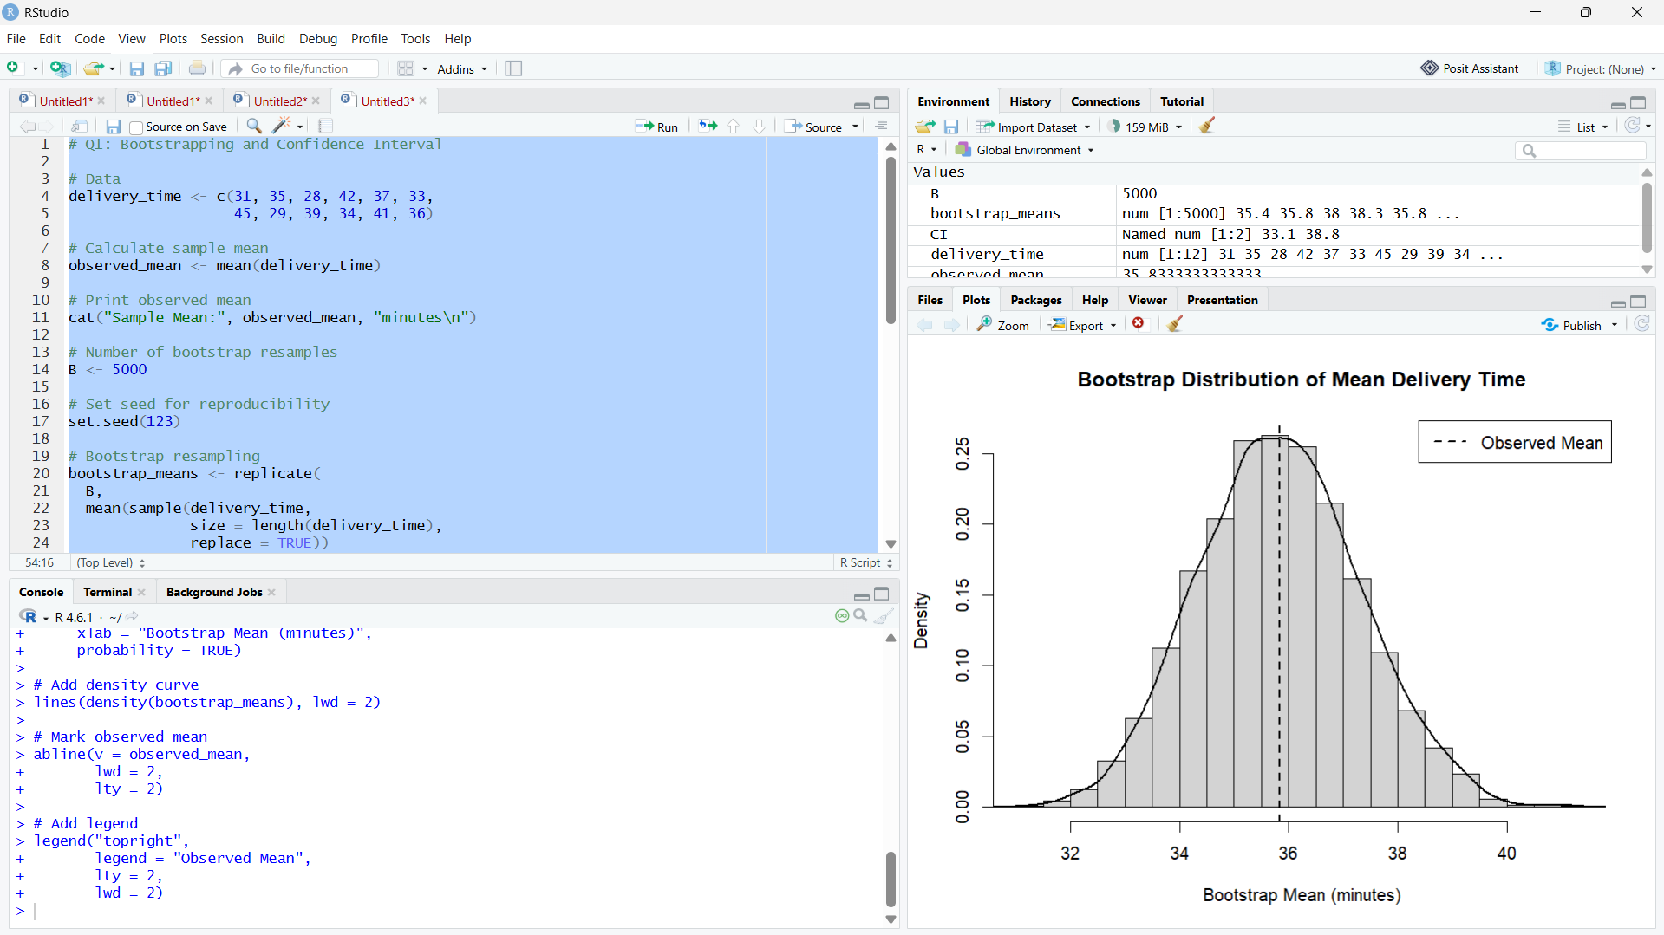

Q2 — Uncertainty in Trend Estimation
The question asks you to fit a linear regression model, plot the observations with the fitted regression line and 95% confidence band, and explain how uncertainty changes across advertising expenditure.
# Q2: Uncertainty in Trend Estimation

# Load ggplot2
library(ggplot2)

# Data
Advertising <- c(10, 12, 15, 18, 20, 23,
25, 28, 30, 33, 36, 40)

Sales <- c(48, 51, 53, 57, 60, 61,
66, 69, 72, 75, 79, 84)

# Create data frame
data <- data.frame(Advertising, Sales)

# Fit linear regression model
model <- lm(Sales ~ Advertising, data = data)

# Display model summary
summary(model)

# Create regression plot with 95% confidence band
ggplot(data, aes(x = Advertising, y = Sales)) +
geom_point(size = 3) +
geom_smooth(
method = "lm",
formula = y ~ x,
level = 0.95,
se = TRUE
) +
labs(
title = "Advertising Expenditure vs Sales",
x = "Advertising Expenditure",
y = "Sales"
) +
theme_minimal()

If you also need the predicted values and confidence interval:
# Create prediction data
new_data <- data.frame(
Advertising = seq(min(Advertising),
max(Advertising),
length.out = 100)
)

# Calculate 95% confidence interval
predictions <- predict(
model,
newdata = new_data,
interval = "confidence",
level = 0.95
)

# Combine results
result <- cbind(new_data, predictions)

# Display results
print(result)

Interpretation
There is a positive linear relationship between advertising expenditure and sales: as advertising expenditure increases, sales generally increase.
The 95% confidence band represents uncertainty around the estimated mean sales trend. It is generally narrower near the center of the advertising range and becomes wider toward the extremes because there is less information for estimating the mean trend there.
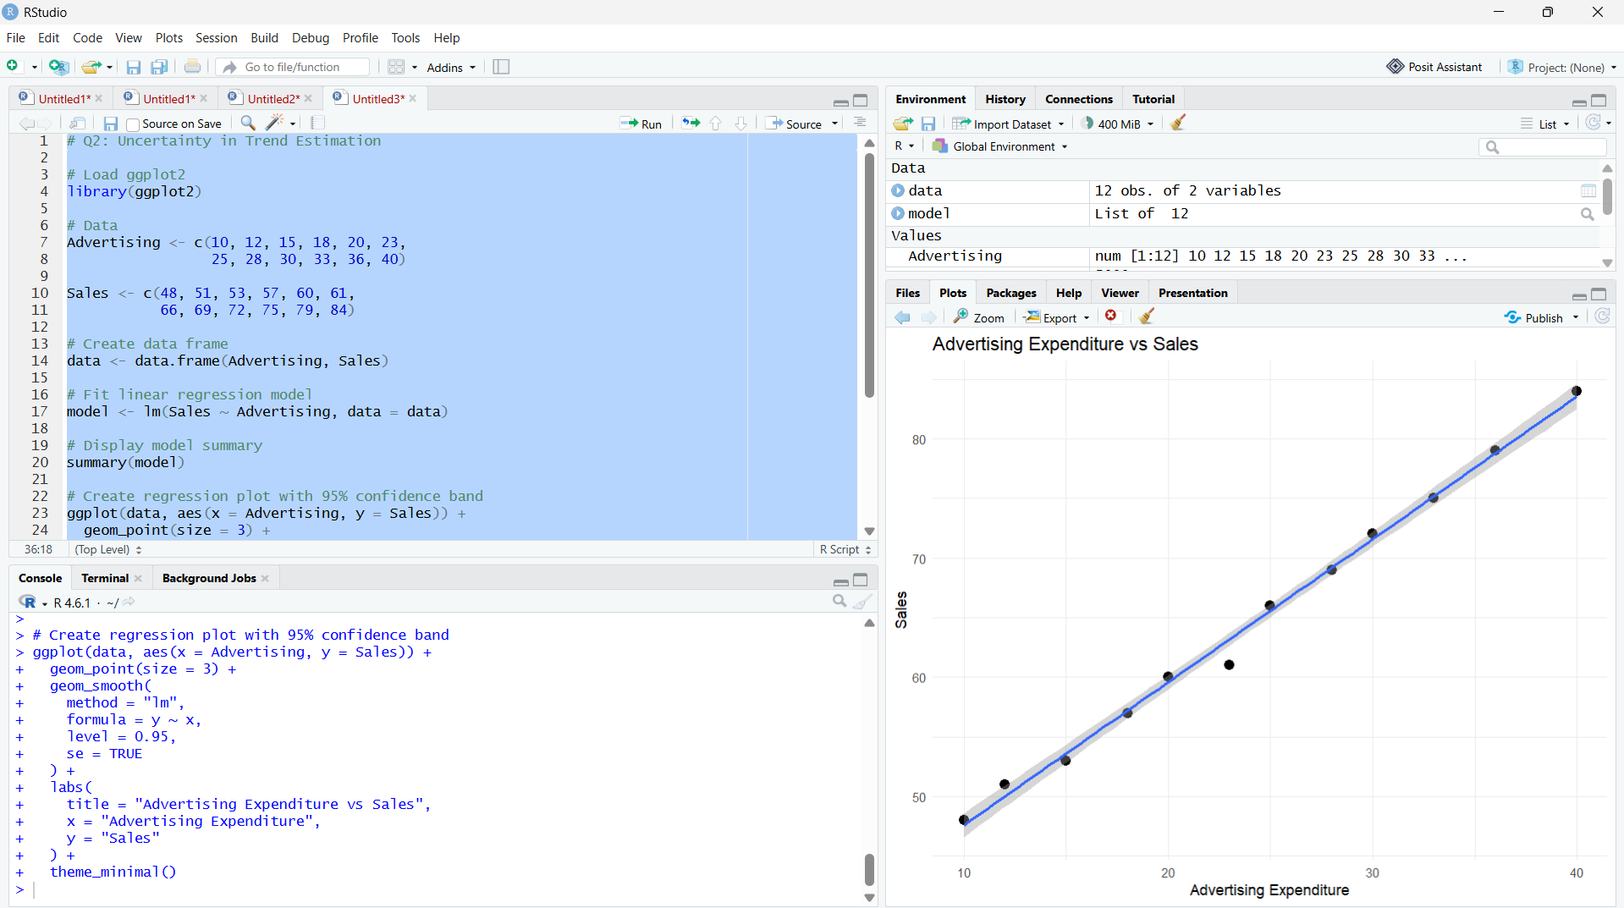

Q3 — Overplotting, Jittering and Transparency
The question asks you to create two scatterplots: first without modification, then using transparency (alpha) and jittering. You then compare how overplotting affects interpretation.
# Q3: Overplotting, Jittering and Transparency

# Load ggplot2
library(ggplot2)

# Data
Hours <- c(2,3,3,4,4,4,5,5,5,5,
6,6,6,6,6,7,7,7,7,7,
8,8,8,8,8,9,9,9,10,10)

Scores <- c(45,52,52,58,60,60,64,66,66,66,
70,72,72,72,72,76,78,78,80,80,
84,84,85,85,85,88,90,90,94,94)

# Create data frame
data <- data.frame(Hours, Scores)

# -----------------------------------
# Plot 1: Original Scatterplot
# -----------------------------------

ggplot(data, aes(x = Hours, y = Scores)) +
geom_point() +
labs(
title = "Original Scatterplot",
x = "Hours Studied",
y = "Examination Score"
)

# -----------------------------------
# Plot 2: Transparency + Jittering
# -----------------------------------

ggplot(data, aes(x = Hours, y = Scores)) +
geom_point(
alpha = 0.5,
position = position_jitter(
width = 0.15,
height = 0.8
)
) +
labs(
title = "Scatterplot with Jittering and Transparency",
x = "Hours Studied",
y = "Examination Score"
)

Comparison / Interpretation
Original plot:
Several students have identical hours studied and examination scores. Therefore, some points overlap, making it difficult to determine how many observations are present at the same location.
Jittering + transparency plot:
Jittering slightly separates overlapping points, while transparency makes areas with multiple observations more visible. This provides a clearer representation of the distribution of students.
Pitfall:
Overplotting can hide observations and make the frequency or concentration of data points difficult to interpret.

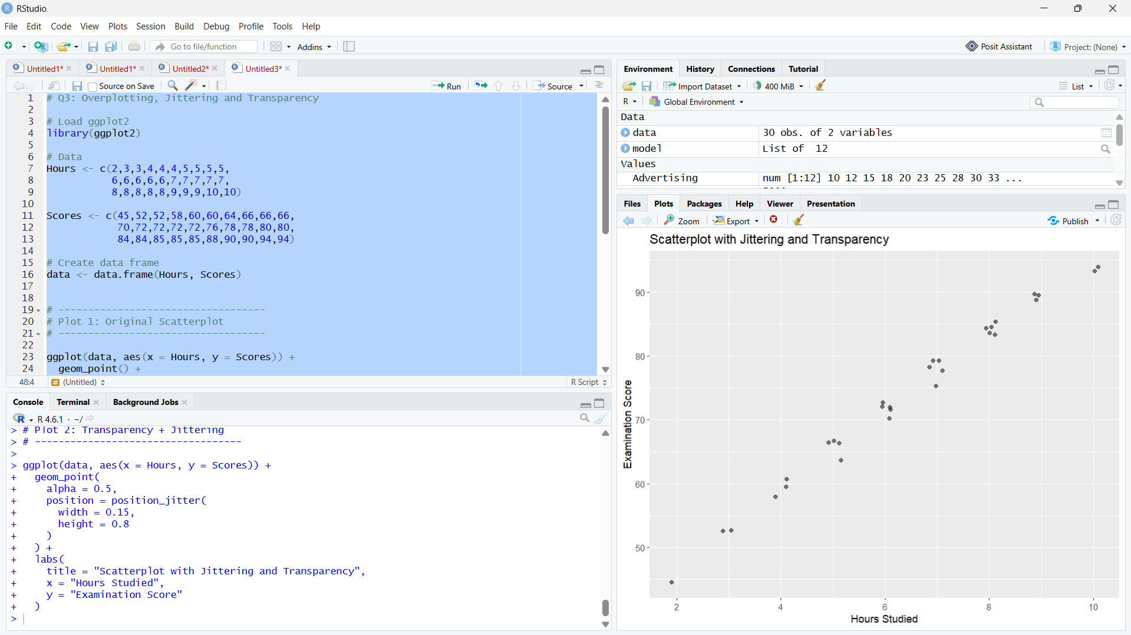

Q4 — 2D Histogram and Density Estimation
The question asks you to create a 2D histogram and a 2D density visualization, then identify the regions with high observation density and compare which visualization communicates concentration more clearly.
# Q4: 2D Histogram and Density Estimation

# Load ggplot2
library(ggplot2)

# Data
Height <- c(150,152,155,158,160,161,163,165,166,168,
170,171,173,175,176,178,180,182,184,186)

Weight <- c(48,50,53,55,57,59,60,62,64,65,
68,69,71,73,74,77,80,82,85,88)

# Create data frame
data <- data.frame(Height, Weight)

# -----------------------------------
# Plot 1: 2D Histogram
# -----------------------------------

ggplot(data, aes(x = Height, y = Weight)) +
geom_bin2d(bins = 6) +
labs(
title = "2D Histogram of Height and Weight",
x = "Height (cm)",
y = "Weight (kg)"
)

# -----------------------------------
# Plot 2: 2D Density
# -----------------------------------

ggplot(data, aes(x = Height, y = Weight)) +
geom_density_2d() +
geom_point() +
labs(
title = "2D Density Plot of Height and Weight",
x = "Height (cm)",
y = "Weight (kg)"
)

Interpretation
- The 2D histogram divides the height-weight space into bins and shows where observations are concentrated.
- The 2D density plot uses density contours to show regions of higher and lower concentration.
- The observations show a clear positive relationship: as height increases, weight generally increases.
- The 2D density plot communicates concentration more clearly because the contour lines make the areas of higher observation density easier to identify.
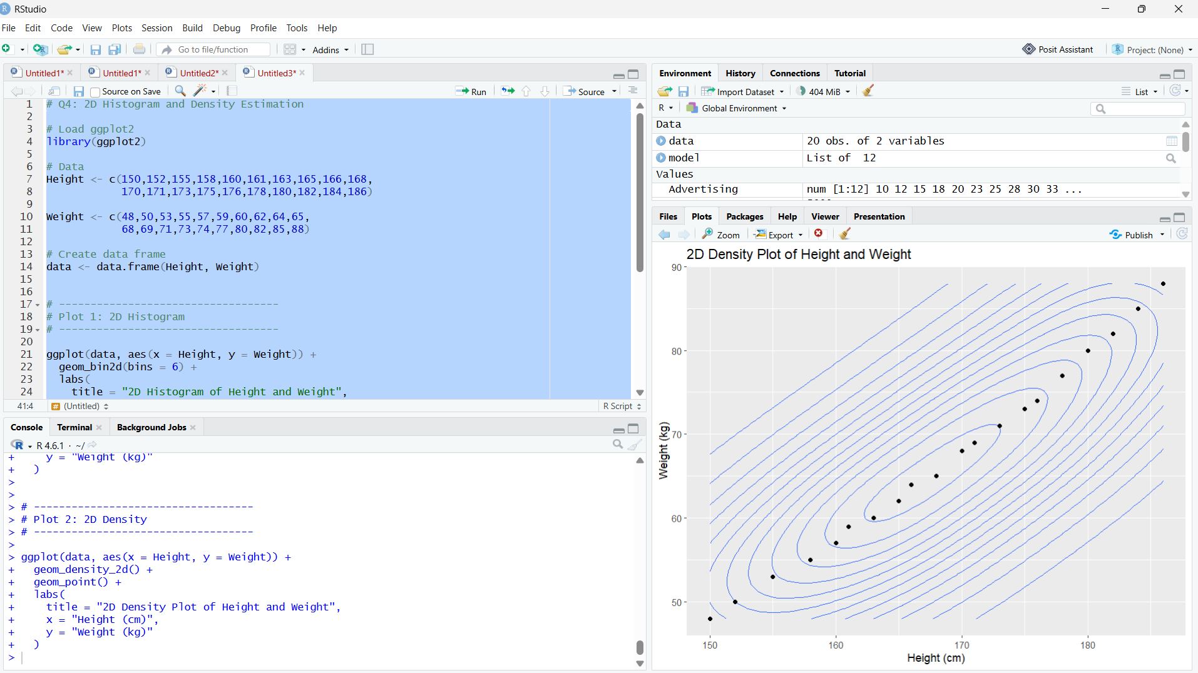

Q5 — Color Scales, Accessibility and Misleading Visualization
The question asks for two plots: one using a potentially misleading nonmonotonic/diverging color scheme, and a redesigned version using an ordered, color-vision-deficiency-friendly sequential scale.
# Q5: Color Scales, Accessibility and Misleading Visualization

# Load ggplot2
library(ggplot2)

# Data
Category <- c("A", "B", "C", "D", "E", "F", "G")

Satisfaction <- c(42, 48, 55, 61, 67, 74, 82)

# Create data frame
data <- data.frame(Category, Satisfaction)

# -----------------------------------
# Plot 1: Misleading Diverging Colors
# -----------------------------------

ggplot(data, aes(x = Category,
y = Satisfaction,
fill = Satisfaction)) +
geom_col() +
scale_fill_gradient2(
low = "blue",
mid = "white",
high = "red",
midpoint = 61
) +
labs(
title = "Satisfaction Using a Diverging Color Scale",
x = "Category",
y = "Satisfaction Score",
fill = "Satisfaction"
)

# -----------------------------------
# Plot 2: Sequential Color Scale
# -----------------------------------

ggplot(data, aes(x = Category,
y = Satisfaction,
fill = Satisfaction)) +
geom_col() +
scale_fill_viridis_c(
option = "viridis"
) +
labs(
title = "Satisfaction Using an Accessible Sequential Scale",
x = "Category",
y = "Satisfaction Score",
fill = "Satisfaction"
)

Interpretation
Plot 1: The diverging color scheme uses different colors around a midpoint. This can imply that values below and above the midpoint represent two different opposing categories, even though satisfaction is a single ordered variable.
Plot 2: The sequential viridis scale represents the values in an ordered progression and is designed to be more accessible for people with color-vision deficiencies.
Visualization pitfall: The first plot can be misleading because the diverging colors may create an artificial distinction around the midpoint rather than clearly communicating that satisfaction scores form a continuous ordered scale.
